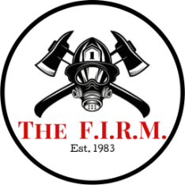

This section for The F.I.R.M. use only.
Order #
This form must be filled out

Firefighter PPE Alteration & Customization Form

Department |  | Phone #
PPE Officer Contact |  | E-mail
F.D. address
( for return shipping)
Name (First & Last) |  | PO #
Rank |  | Shift
ID # |  | Station #
Please fill out to the best of your knowledge as the information will be used for tracking purposes and NFPA reports supplied to your department.
PPE items sent in, please check all that apply

Item QTY |  | New Used  from  factory | Repair Please Note Misc.  Type of  Contaminants |  |  | Alteration  Current New  size size
Coat  Ser# |  |  |  |  | DRD  Yes No
Pant  Ser# |  |  |  |  | Susp.  Yes No
Hood |  |  |  |  |  | Customization notes:
Helmet

Gloves
Boots |  |  |  |  |  |  | size
Mask
Gear Bag
*Please perform a complete pockets check and remove all miscellaneous items before shipping your PPE. The F.I.R.M. takes great care in itemizing inventory of pocket contents, but will not be held responsible for missing miscellaneous items.

Please indicate customization / special instructions & any damage found that need particular attention.
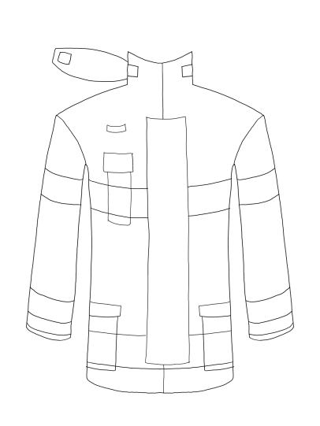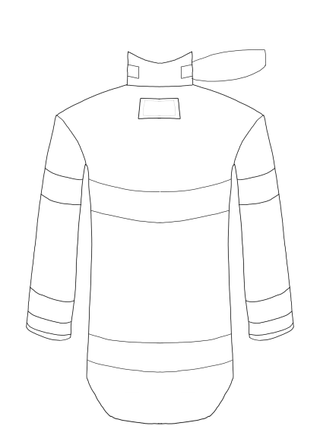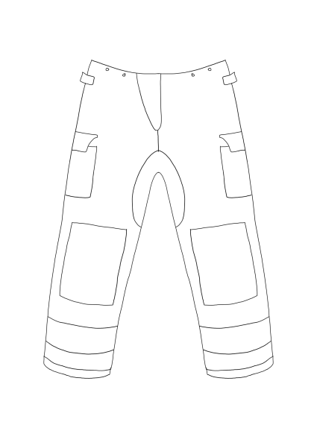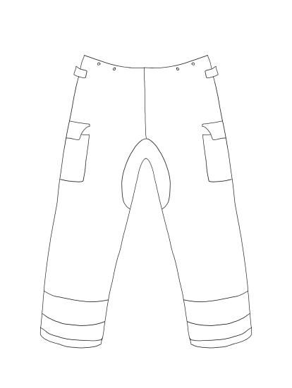
Signature: ___ ________________________________________________ Date: _ ____
*By signing you have verified that all items stated above have been sent in for cleaning and repair. Any paperwork not filled out will not be processed.
The F.I.R.M. PPE Firefighter Tracking Form 2020

